2020 Census: Counting the Homeless
People experiencing homelessness will be counted by the Census Bureau between March 30 and
April 1, 2020. The Census Bureau will count persons experiencing homelessness at shelters, soup kitchens, meal drop-off locations, and identified outdoor locations.
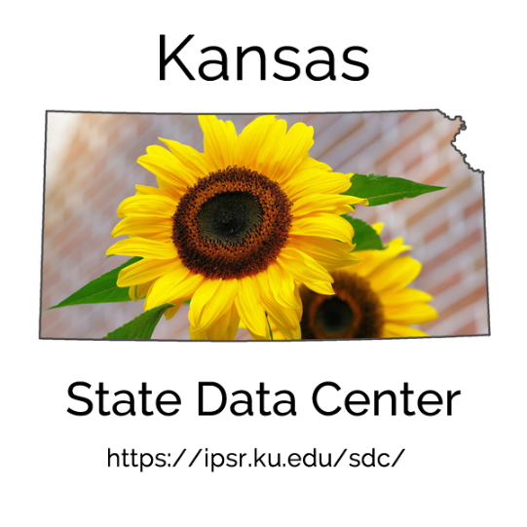
What Information is Collected?
People contacted through an in-person interview will be asked:
- First and last name
- Sex
- Date of birth
- Age on census day
- Race
- Hispanic origin
- An alternate address where they live or stay when not at a facility

Census Bureau enumerators will visit designated locations between March 30 and April 1, 2020 to collect as complete an enumeration as possible.
How is Information Collected?
- The primary method of collection will be through in-person interviews. A census enumerator will conduct interviews with people receiving services on a given day.
- For people living in an emergency or transitional shelter, a Census Bureau worker will meet with the facility contact to obtain information for each person served or staying at the facility on Census Day.

Where are People Counted?
The Census Bureau counts people experiencing homelessness at multiple locations including:
- Emergency and transitional shelters where people stay overnight
- Soup kitchens
- Regularly scheduled mobile food vans
- Targeted non-sheltered outdoor locations

