2020 Census: Counting College Students
and Other People in Institutions
The goal of the 2020 Census is to count everyone once, only once, and in the right place. Where people should be counted depends on where they are living on Census Day, April 1, 2020.
People Living in Other Institutions and Group Settings
People living in group homes, nursing homes, prisons, military bases, or other institutions will be counted at their institution through the Group Quarters Enumeration.

College Students
- A college student living in a dormitory or apartment owned by their college will be counted at their college through the Group Quarters Enumeration.
- A college student living at home will be counted on their parents’ census form.
- A college students living off-campus, but not at their parents’ home, will receive an invitation to complete the census at their residence.

People living in college dormitories and other group or institutional settings will be counted as part of the Group Quarters Enumeration.
What is Group Quarters Enumeration?
- People living in group quarters do NOT complete census forms; rather the administrators of a facility submit census forms for the facility.
- These forms do not enumerate individuals living in a facility, but rather aggregate counts of residents, including key demographics. Data are collected through an in-person interview with an enumerator or through a paper form.

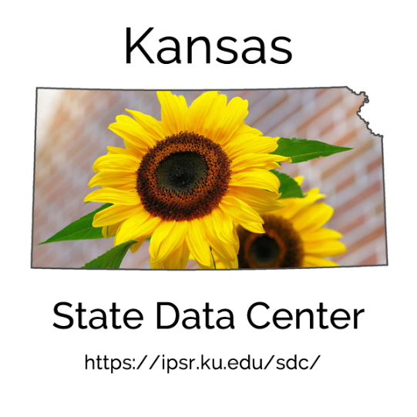
People Experiencing Homelessness
People experiencing homelessness will be counted through a special process described in the “Counting the Homeless” fact sheet, available at: https://bit.ly/2Mk0H8N.

