2020 Census Basics
The goal of the 2020 Census is to count everyone once, only once, and in the right place. The Census Bureau will continue to improve its use of mobile technology, geospatial innovations, and internet self-response.

It’s Important. It’s Easy. It’s Safe.
Who should respond?
- EVERYONE! Census mailings will be sent to all households in the U.S. to collect information about every person living in the household.
- The Census Bureau is conducting special counts for people living in group quarters (college dormitories, prisons, nursing facilities) or who are unsheltered.

When is the 2020 Census?
- Census Day is April 1, 2020. Data collection will begin in March 2020 and continue through August 2020.
- Households will receive a postcard with instructions for completing the census beginning in March 2020. The Census will NOT call or email you.

How can people respond to the census?
The Census Bureau will offer the census form in four ways:
Online, using the internet or a smartphone,
Over the telephone, by calling the Census
call center listed on the Census postcard,

Using a paper form, or

By responding to a Census enumerator.
Census forms are available in 13 languages and language guides (video and print) available in 59 non-English languages as well as American Sign Language, braille, and large print.
What is the census?
- The census is a count of all persons living in the United States that is conducted every ten years by the federal government and is required by the U.S. Constitution.
- It is used to determine the number of seats each state has in the House of Representatives, how federal and state legislative districts are redrawn, and the appropriation of federally funded programs.

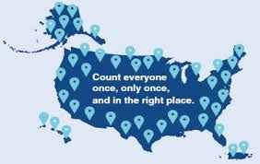
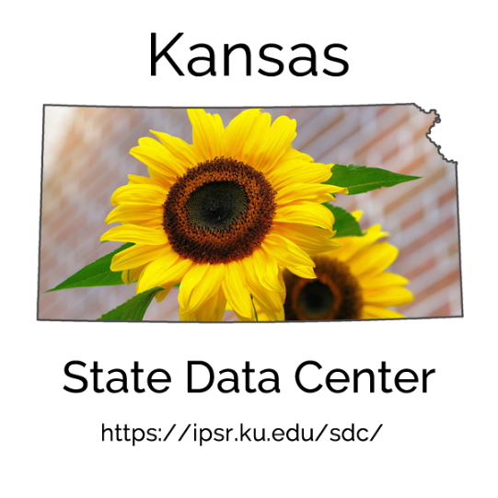
10
Are census responses confidential?
- All data are protected under Title 13 of the U.S. Code. Records are confidential for 72 years by law. All Census Bureau employees swear a lifetime oath to protect respondent information. The penalty for wrongful disclosure is up to 5 years imprisonment and/or a fine of $250,000.
- The Census Bureau will never share a respondent’s personal information with other government agencies.
- Data are only released in summary tables, no individual records are released.

Learn more about the 2020 Census
- https://www.census.gov/programs-
surveys/decennial-census/2020-census.html
- https://ipsr.ku.edu/ksdata/census/2020/
Do people have to answer all census questions?
While the law requires persons to answer all census questions accurately, an incomplete census form will still be included in the head count.
What questions will be asked?
Eleven questions, approximately 10 minutes per person
● Name ● Relationship to householder
● Phone number ● Household tenure (own/rent)
● Age ● Number of people in household
● Sex ● Usual place of residence
● Race ● Citizenship
● Hispanic origin
Did you know…
Census counts are used in distributing over $6 billion in federal funds EVERY year in Kansas. This translates to $2,082 per person per year.
These dollars help fund:
- Education
- School Lunch programs
- Head Start programs
- Women, Infants, and Children (WIC)
- State Children’s Health Insurance
Program
- Supplemental Nutrition Assistance
Program (SNAP)
- Temporary Assistance for Needy
Families (TANF)
- Transportation
- Community Development Block
Grants (CDBG)
See funding to Kansas from 55 large
federal programs at: https://tinyurl.com/countingfordollars

